**UNIVERSITY OF BUEA**

**\*\*\*\*\*\*\*\*\*\*\*\*\*\*\*\*\*\*\*\*\*\*\*\*\*\*\*\*\*\*\*\*\*\***

**FACULTY OF ENGINEERING AND TECHNOLOGY**

**\*\*\*\*\*\*\*\*\*\*\*\*\*\*\*\*\*\*\*\*\*\*\*\*\*\*\*\*\***

**DEPARTMENT OF COMPUTER ENGINEERING**

**\*\*\*\*\*\*\*\*\*\*\*\*\*\*\*\*\*\*\*\*\*\*\*\***

**CEF 440: MOBILE PROGRAMMING**

**\*\*\*\*\*\*\*\*\*\*\*\*\*\*\*\*\*\*\*\***

**LEVEL 400: 2022/2023 ACADEMIC YEAR**

**Project Title:**

**DESIGN AND IMPLEMENTATION OF A PASSENGER POSITIONING SYSTEM**

**TASKS 5:**

**UI DESIGN AND IMPLEMENTATION**

**Supervisor:**

**DR NKEMENI VALERY**

**Group 8 Members:**

|  |  |
| --- | --- |
| **NGI KEVIN AYUK** | **FE20A076** |
| **NDEM LARRY NCHENY** | **FE20A071** |
| **TASHA MBIJINUI OLIVIA** | **FE20A0112** |
| **TAGHA WILFRED** | **FE20A0122** |
| **A. CLINTON MBURLI** | **FE20A010** |

Table of Contents

INTRODUCTION 3

TOOLS 3

USER DESIGN FLOW 3

PASSENGER SPECIFIC PAGES 4

DRIVER SPECIFIC PAGES 5

IMPLEMENTATION 6

# INTRODUCTION

User Interface (UI) refers to any method or means by which the end-user of a product interacts with or controls a product, software or hardware device. This includes screens, keyboards or a mouse.

# TOOLS

* Figma
* Andriod studio
* Visual studio
* Visual Studio code

# USER DESIGN FLOW

When you get into the app, the screens flow is as follows.

* SPLASH SCREEN: This screen welcomes you into the app.
* GET STARTED: Here you get to select if you are a passenger or a driver.
* LOGIN: If you already have an account. You will log in else you select the option to sign up.
* SIGN UP: Either as a passenger or a driver, you will be presented this screen.

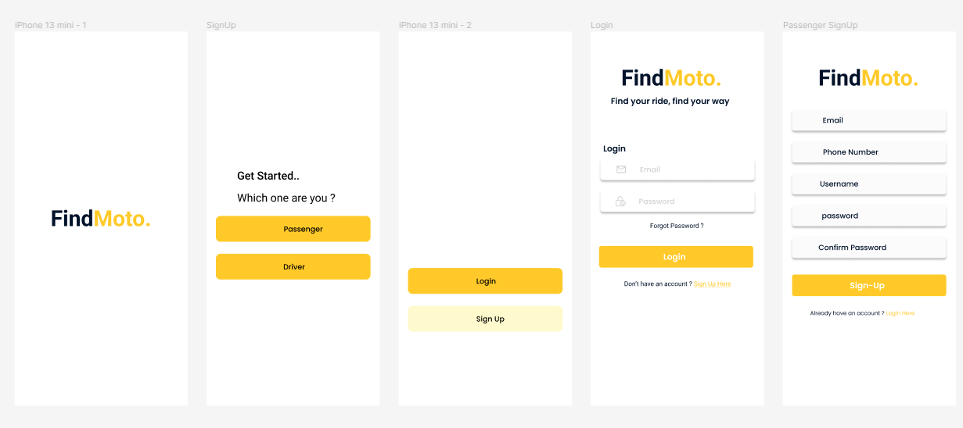

After signing up, a code will be sent to your mobile number. You will input the number and submit.

In case you forgot your password, you will also be presented a chance to change your password.

* DRIVER AUTHENTICATION: In case you signed up as a driver, you will be directed to this screen. Here, you will be able to upload your documents. This is necessary for security purposes to make sure the drivers are truly drivers.

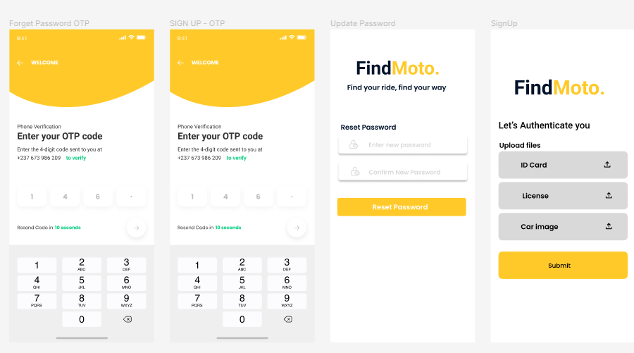

## PASSENGER SPECIFIC PAGES

When u successfully get locked-in a passenger, you are presented the following screens below int the order in which they are presented in this document.

* PASSENGER OTP: This is the first page that opens. In this screen, links to other screens are displayed here. More on these screens are given below.
* BOOK RIDE: Here, passengers are able to book a taxi based on three of the criteria given: Price, Time, Location. This is where the system implements passenger matching.
* RIDE COMPLETE: On this screen, you see if your ride was accepted or not.

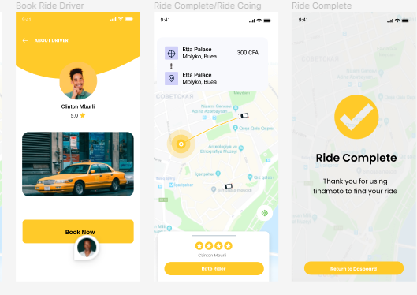

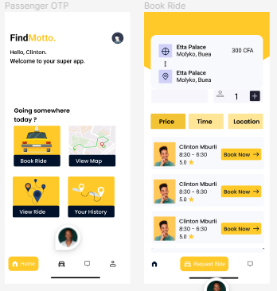

## DRIVER SPECIFIC PAGES

When you succeed to login as a driver, you are presented with the following screens below.

* DRIVER DASHBOARD: The driver is presented with the option to view ride request, view the map, see notifications or history.
* VIEW RIDE REQUEST: Here the driver views all passengers that requested for a ride. He can tap on it to either accept or decline it.
* VIEW MAP: Driver can click on it to view the passenger/ driver congestion in any specific area of his choice.

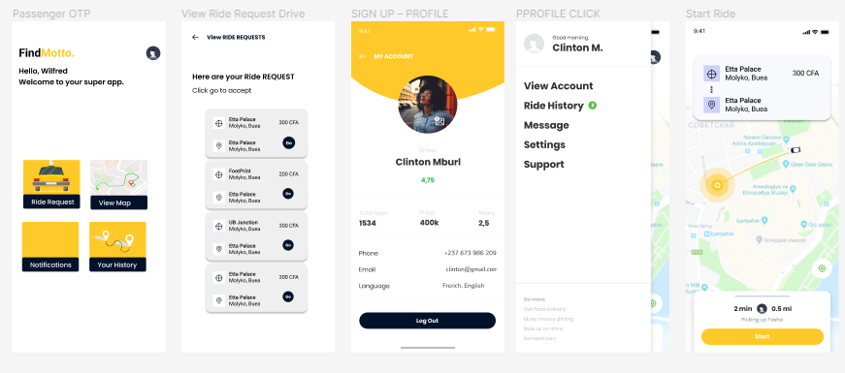

# IMPLEMENTATION

The app was implemented using flutter and dart on android studio and VS code. You will find attached to this the implementation code.